|  |  |
| --- | --- |
|  | **Cruise Ship Management**  **Technical Design Document** |
| |  |  |  |  | | --- | --- | --- | --- | |  | **Prepared By / Last Updated By** | **Reviewed By** | **Approved By** | | **Name** | Shrish Nandakumar |  |  | | **Role** |  |  |  | | **Signature** |  |  |  | | **Date** |  |  |  | |
|  |

Table of Contents

1.0 Introduction 3

1.1 Purpose of this document 3

1.2 Project overview 3

2.0 Solution Summary 3

2.1 Scope 3

2.2 Assumptions 3

2.3 Dependencies 3

2.4 Risks 3

3.0 Schematic Diagram 3

4.0 System Design 4

4.1 Proposed design 4

4.2 Component inventory 4

5.0 Database Design 4

5.1 Data Model 4

5.2 Tables Structure 4

6.0 Appendices 4

6.1 Glossary 4

6.2 Other 5

7.0 Terms & Conditions 5

8.0 Change Log 5

# Introduction

## Purpose of this document

The purpose of this document is to document the technical design, component details and Database design. This will also capture the scope, assumptions, risk, dependencies of this project.

## Project overview

*<This sub-section shall state the overview of the project >*

# Solution Summary

## Scope

*<This sub-section shall state the scope of this detailed design document>*

## Assumptions

*<This sub-section shall state the assumptions of this detailed design document>*

## Dependencies

*<This sub-section shall state the dependencies for this project>*

## Risks

*<This sub-section shall state the risks predicted for this project>*

# Schematic Diagram

# System Design

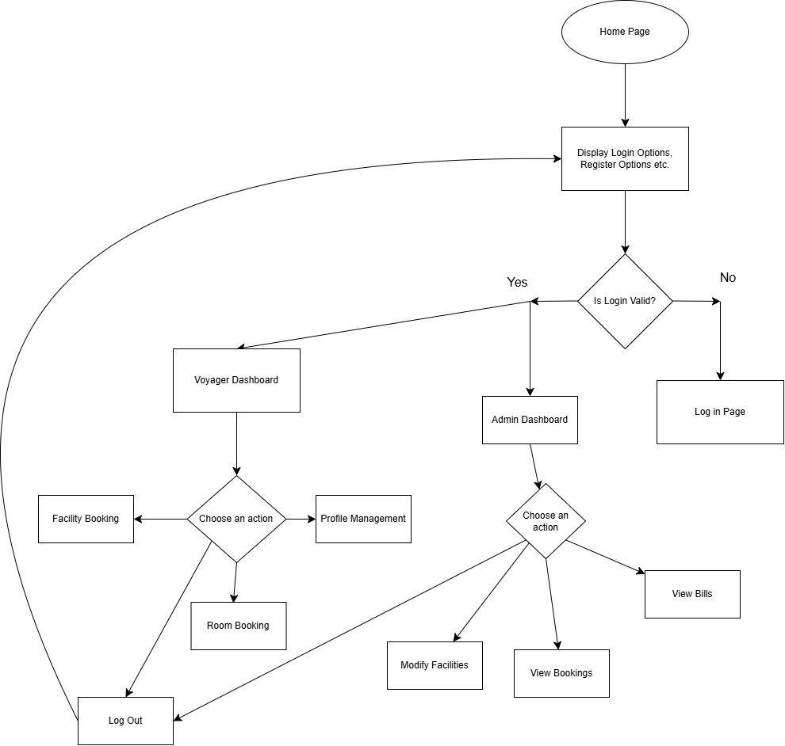

# Database Design

## 

## Tables Structure

*<This sub section will describe the table structure>*

|  |  |  |  |
| --- | --- | --- | --- |
| **Column Name** | **Data Type** | **Length** | **Nulls** |
|  |  |  |  |

# Appendices

## Glossary

|  |  |
| --- | --- |
| **Acronyms** | **Definitions** |
|  |  |

## Other

# Terms & Conditions

***Disclaimer: Please do not circulate or distribute this document outside of Cognizant Network, We have a Zero Tolerance Policy. Kindly adhere to 100% Compliance at all times.***

# Change Log

*Please note that this table needs to be maintained even if a Configuration Management tool is used.*

|  |  |  |  |  |
| --- | --- | --- | --- | --- |
| Version Number | Changes made | | | |
| V<n.n> | *<If the change details are not explicitly documented in the table below, reference should be provided here>* | | | |
| Page no | Changed by | Effective date | Changes effected |
|  |  |  |  |
|  |  |  |  |
|  |  |  |  |
|  |  |  |  |